Online Donations

**Problem ID** SCHR036

**Problem Statement** Smart App for donation food, books, clothes etc.

**Synopsis Abstract**

Our android application is all about online donations of food, clothes, and books through NGOs where the donor or the user can donate these items according to his/her choice.

In this app, we will provide three options to the donor.

After selecting one of the options for donation, the donor has to fill all the personal details in the form and, most importantly, post the picture on the app, be it food, clothes, or books in all the three scenarios it is a must.

So now, after filling all the details and pictures when he chooses any of the three options and clicks submit button after that NGO will contact the donor.

Through our app user can donate online without any hustle or problem and there is no exiting app in the market which has this functionality in it, and there are apps that only work for a single NGO.

**Literature Review/Existing Innovation-technology**

 There are currently a few web pages that focus on book donation, food donation, and clothes as well as toys, but there are some problems in them.

 Following are some existing web apps:-

 Zomato’s philanthropist trust [www.feedingindia.org](http://www.feedingindia.org):- This website is part of Zomato’s philanthropist trust, which is an online food delivery app, and it is a part of their corporate social responsibility. They collect extra food from the restaurant listed on their app and distribute it in nearby slums or homeless.

 Robin Hood Army [www.robinhoodarmy.com](http://www.robinhoodarmy.com):-This an NGO which collects food from parties, wedding, and restaurant with the help of volunteers across the country. They distribute food to slums or homeless. They don’t acquire any funding.

Uday Foundation [www.udayfoundation.org:-](http://www.udayfoundation.org:-) This NGO collects money from the crowd for food to feed to the homeless, hospitals, and patients as well as collect clothes and distribute them.

HBE - Donate Food Cloths Books android application: - It is a non-profit organization that collects extra food, clothes, and books from the doorstep. They work in Greater Noida and Coimbatore city only. Also, they don’t integrate different NGO’s

All current solutions in this domain either work with a particular organization or city or production.

Our Application aims to work across the country, and all NGO’s and non-profit organizations working in this domain can integrate into one platform.

**Approach to solve the problem**

Our approach would be like in this manner--  
Our first task would be to integrate all the licensed NGOs of the city on a common platform location wise.  
We would ensure that in the case of food donation, NGOs will take food only from the authorized and legal organizations only like any licensed restaurant or food catering company. By doing this we will ensure the food quality and the safety of those people who are going to consume that food.  
We will also ensure that the identity of the donor is genuine and not fake and also check the quality of books and clothes that are going to be donated to the needy people.

**Road map/Flow diagram to develop final solution**

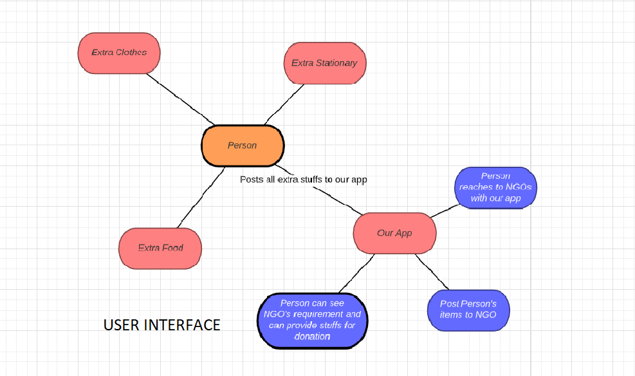 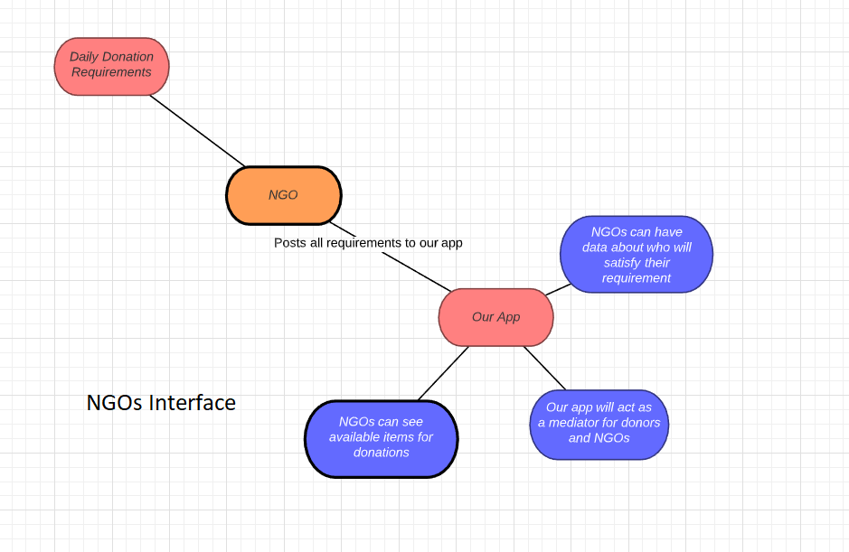

**Tools and technologies to be used to solve the problem**

We have used the following technologies and tools:-

Android's Native development kit: - It is a set of tools that allows you to use C, C++ code, and other technologies other than Android with Android.

Android software development kit: - is a set of development tools used to develop applications for the Android platform.

Firebase Database: - The Firebase Real-time Database is a cloud-hosted NoSQL database that lets you store and sync data between your users in real-time.

Firebase Storage: - Cloud Storage for Firebase is a powerful, simple, and cost-effective object storage service built for Google scale. The Firebase SDKs for Cloud Storage add Google security to file uploads and downloads for your Firebase apps, regardless of network quality.

We are targeting Minimum SDK 21 and Maximum SDK 29 for android development.

**Challenges/Risk in implementing**

We faced many challenges during the implementation of our android application.

First of all, it was very tough to convince all NGO authorities to be part of our app and make them believe that charity can be done through the internet also. Some NGO was not ready to be part of our project, but in the end, we convinced them.

Secondly the most important of all, the food quality of the donated food.

We had to meet the esteemed organizations related to food like any big catering company or licensed restaurants and make them believe in our project.

We cannot associate with local people or typical houses for food donation because there is no guarantee that if no one shows up at the delivery spot for donation after applying for donation on our app, who will be responsible for this?

**Possible outcome**

We target to integrate nationwide all Ngo’s and non-profit organization which works in food, books, and clothes domain into one platform. We want to create a bridge between donors and NGO or non-profit organization which do welfare of society suppose a person has extra clothes at his/her house and doesn’t have time or doesn’t know where to donate the clothes there are product can help. This application can make people more socially aware of the society. We want to create a sense of responsibility in common man. Our application will reduce carbon footprint as food wastage will be reduced and as well as old clothes and books can be reused.

**Work done till date**

Our Online Donations app opens with a login/registration window.

After this, when the user logs into our app, the front page of the app contains a top section which contains the daily NGO's requirements. Another section contains today's top donations.

And the next section contains NGO partners.

Footer contains profile button, home button, notification icon and 'plus' button to donate and there is a Show All NGOs button also, and there is a logout button.

By clicking on the profile icon, the donor can see his/her details. The donor can change his/her profile picture using the camera or can select from the galley.

When the donor clicks on 'plus' sign, there will be three options food, clothes or books and a close button to cancel the donation. Then donor will click submit button.

This was the front end of our application. Now comes the back end or in other words, database design or connectivity.

Our database design is done just implementation of database connectivity is left.

This was our work done to date.

**Screenshots:-**

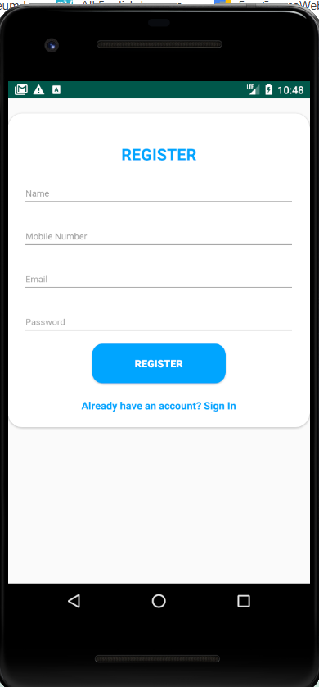

1)Login/SignUp

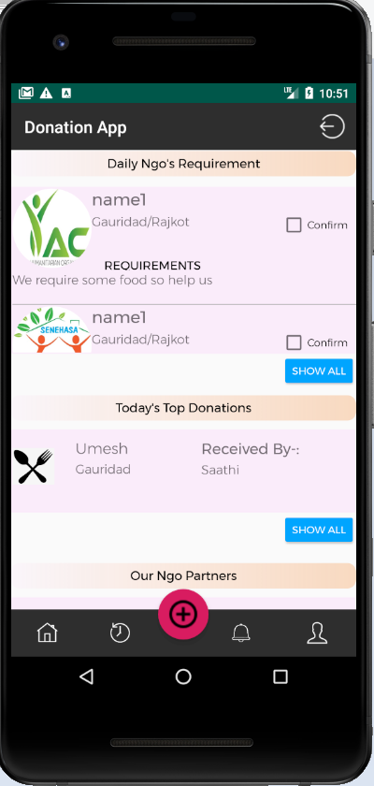

2) User Interface after succesfull login

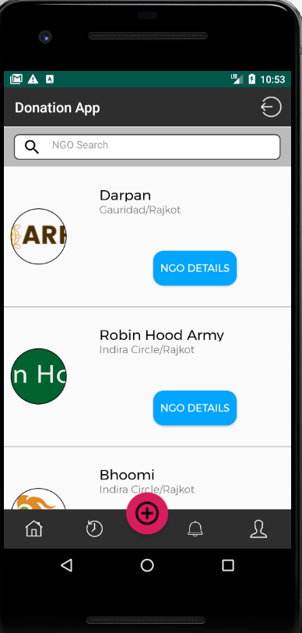

3) Total NGO's List

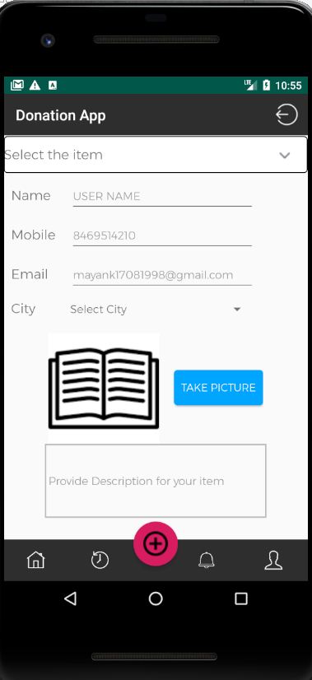

4) Add items for donation(User Side)

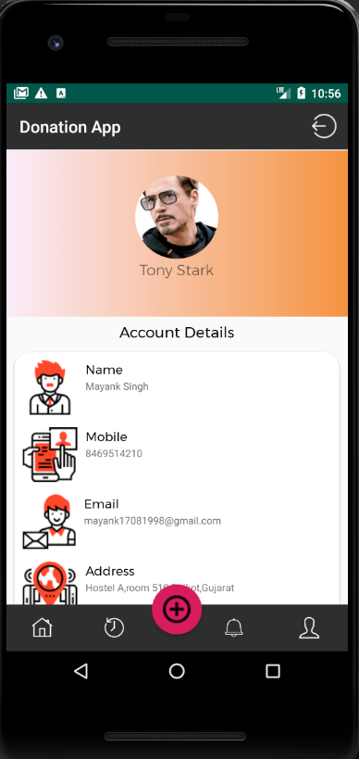

5) Profile(User Side)

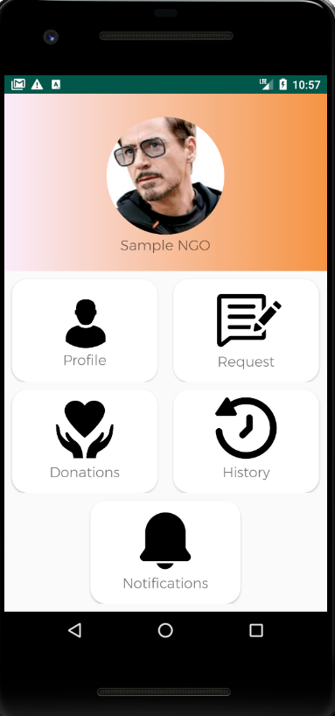

6) NGO interface after login

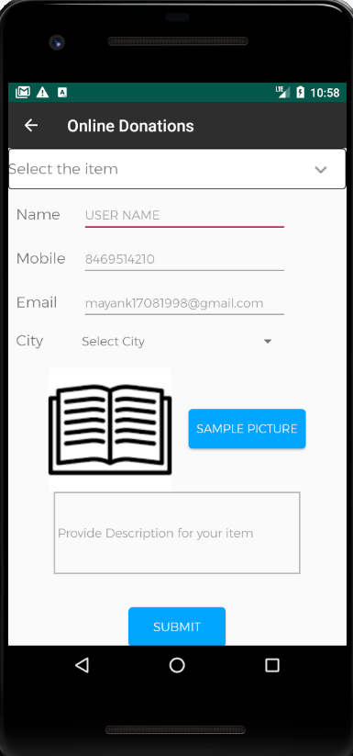

7) Post donation requirements(NGO)

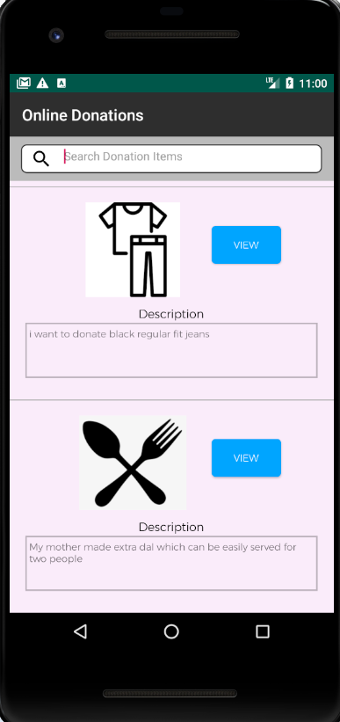

8)Show available donations(NGO side)